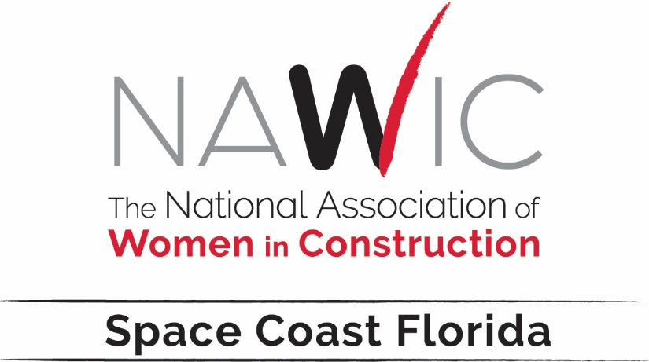
Terri L. Holmes, CIT – President 2021-2022
Report for - Southeast Region Fall Conference 2021

The Space Coast Florida Chapter is the “little Chapter with big ideas”. Our theme for the year is “ON TRACK” – similar to the Florida’s Brightline high speed passenger rail system that is under construction, the Space Coast Florida Chapter is “…on track and moving forward…!”
At this past Annual Meeting the Space Coast Florida Chapter was recognized for its efforts over the past year to maintain its Membership in the 25-member-chapter category. We not only survived through 20-21, we thrived and grew! This year we will continue to treasure our existing Membership and grow, encouraging other professional women in construction to join us, thereby ensuring that we are ON TRACK … AND MOVING FORWARD.
Over the past two years we have successfully developed a Chapter Corporate Sponsorship program to help fund the business and events of the Chapter. It has worked well and we have found that the Members and our Member Companies prefer this form of support over the fund raising events that were held previously. It is a win-win!
Our plans are to continue to:
- Hold Membership Meetings that are fun, uplifting, and educational—keeping with the core purpose of NAWIC which is to “…strengthen and amplify the success of women in the construction industry.”
- Provide interesting, uplifting, and educational speakers at the Membership Meetings. Lisa Burnett is our PD&E Chair. Our first speaker is member Dominique Flickinger, President of ECBCx LLC, explaining Total Building Commissioning.
- Give a minimum of one (1) $1,000 Scholarship to a female student, who will be pursuing a career in a construction related field, and used at a college, university, or trade school within the state of Florida. Bo Strada is our Scholarship Chair.
- Participate in the WIC Week Activities spotlighting all women in construction. Kate Howick and Julie Hood are our WIC Week Co-Chairs and have promised something “over the top”!
- Raise funds for NEF by holding a 50/50 drawing at the monthly Membership Meetings and from time to time collecting pocket change to add to the NEF donation. This past year we donated $510.54 to NEF, pretty good for a “little Chapter with big ideas”. Cheryl Foley is our NEF Chair.
- With the remnants of the Covid pandemic in the schools, we will likely not participate in the Block Kids Competition this year.
As we celebrate the start of our 26th Year as a Chapter, we are thinking BIG, and continuing to try new things. We are …on track and moving forward!

