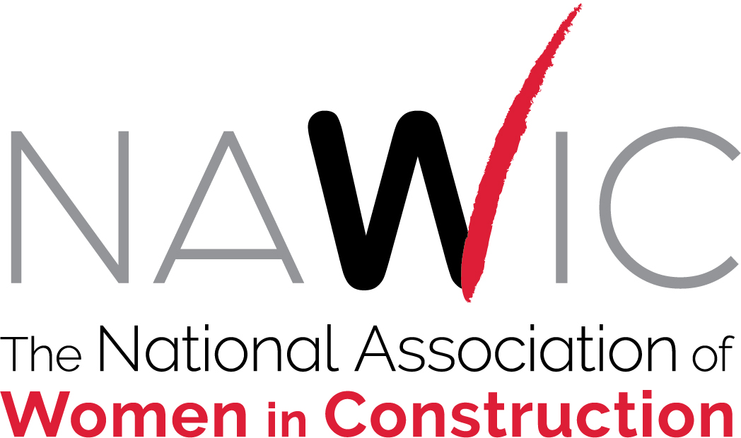

Post-Conference Board of Directors Meeting
Saturday, August 14, 2021
SUMMARY OF ACTIONS
- APPOINTED the following:
  - Vice President Karen Hager as Timekeeper for the 2021-2022 NAWIC Year.
  - Rhonda Nebgen, South Central Region Director and Alison Frye, North Central Region Director as Audit Committee for the 2021-2022 NAWIC Year.
  - Andrea Ward, Southeast Region Director was appointed as Auditor for the 2021 Post-Conference Board of Director’s Meeting replacing Rhonda Nebgen for this meeting only.

- ADOPTED Small Board Meeting procedures for face-to-face, teleconference, and video conference meetings.

- APPROVED Consent Agenda as published
  - Executive Committee Summary of Actions
    - Appointment of Bank Signatories
    - Approval of Executive Director Contract
  - Ratified the Contract of the Executive Director
- Strategic Planning Report and Updates to the Strategic Plan Scorecard

- PROVIDED GUIDANCE clarifying objectives and next steps to the following taskforces:
- Construction Camp Design Taskforce
- Grant Application Process Taskforce

- ADOPTED the Sarbanes-Oxley Policies which include Code of Ethics, Conflict of Interest, Joint Venture Policy, Record Retention and Document Destruction Policy, Whistleblower Protection Policy as amended.

- DISCUSSED the Bylaws Revision Proposal to Article 10 – Region Directors Section 3: Vacancy in the Position of Director
  - APPROVED keeping term/length of service out of updated bylaws proposal
  - SENT to Bylaws Committee to review and revise as needed
  - RECOMMENDED updated proposal to come back before the Board of Directors by the December 8 Board Meeting.

- DEFEATED the Bylaws Revision Proposal to Article 7 – Regions Section 1: Creation of Regions

- APPROVED 2020-2021 Budget as amended

