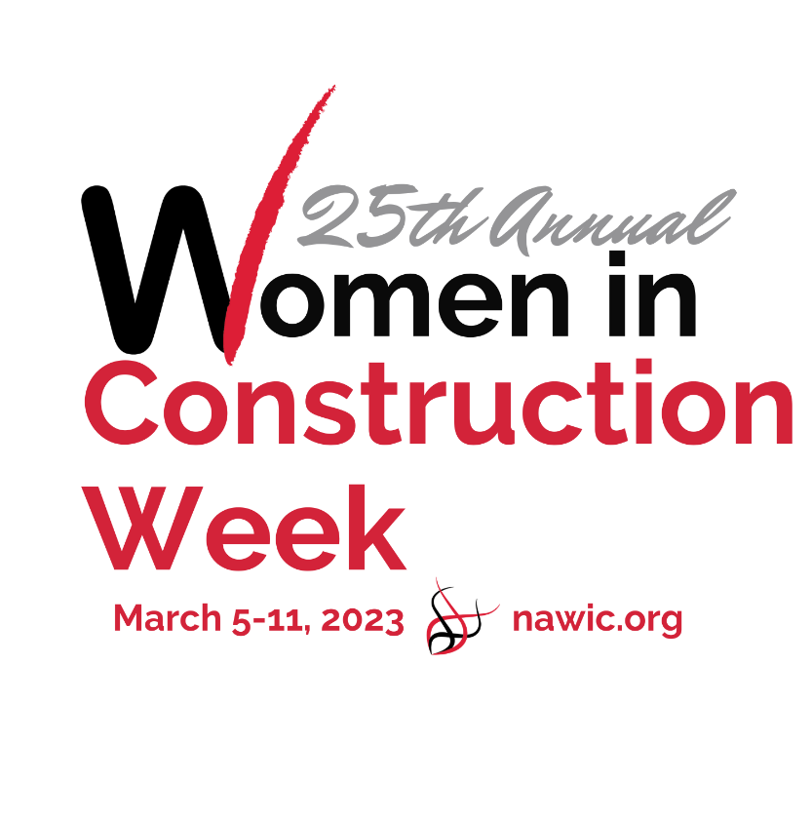
2023 WIC WEEK
RECAP

Chapter Name & No.: _________________________ Region: ________________________________
Contact Name: _______________________________ Email: ________________________________
Phone: _________________________________ Fax: ________________________________
We celebrated WIC Week 2022 with the following event(s) and/or activity(ies):
Monday______________________________________________________________________________
_____________________________________________________________________________________
Event Type __________________________# of People in Attendance___________Non-Member______
Tuesday______________________________________________________________________________
_____________________________________________________________________________________
Event Type __________________________# of People in Attendance___________Non-Member______
Wednesday___________________________________________________________________________
_____________________________________________________________________________________
Event Type __________________________# of People in Attendance___________Non-Member______
Thursday___________________________________________________________________________
_____________________________________________________________________________________
Event Type __________________________# of People in Attendance___________Non-Member______
Friday________________________________________________________________________________
_____________________________________________________________________________________
Event Type __________________________# of People in Attendance___________Non-Member______
Please email This Form to wicweek@nawic.org BY MARCH 25, 2023.

