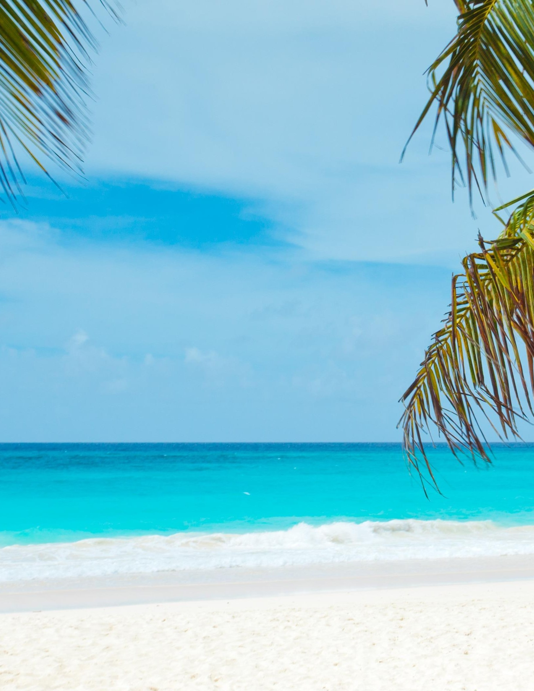
SOUTHEAST REGION FALL CONFERENCE
REGISTRATION FORM NATIONAL ASSOCIATION OF WOMEN IN CONSTRUCTION
DATES: OCTOBER 9-10TH, 2020

EVENT LOCATION HOTEL LOCATION
SOPREMA RESIDENCE INN POMPANO
2900 CENTER PORT CIRCLE 2880 CENTER PORT CIRCLE
POMPANO BEACH, FL 33064 POMPANO BEACH, FL 33064
786-427-3948 954-784-9003

BOOK YOUR ROOM FOR FALL CONFERENCE HERE
Room Rates: King & Double Occupancy $79/night - Taxes not included
*Breakfast included with hotel stay

PLEASE TYPE OR PRINT ALL REQUESTED INFORMATION:
Full Name: Name for Badge: Chapter: No.: Region: Address: City: State: Zip: Employer: Office Phone: Home Phone: Mobile Phone: Email: CHECK ONE: Active/Corporate ( ) Associate ( ) Member at Large ( ) Retired ( ) Student( ) NAWIC Officer (Title) 2019-2020 NAWIC National Board Position

Early Registration Fee ends July 31st: $ 75.00 Late Registration Fee Aug 1: $ 90.00 No Refunds After: September 25th, 2020

Make Checks Payable To: Southeast Region Events Fund PAYPAL LINK
Mail/Email Registration Form To:
Attn: Jeanette Alston-Watkins, SOPREMA, 2900 Center Port Circle, Pompano Beach, FL 33064 jalstonwatkins@soprema.us
Please send email with any Dietary needs: Vegan, Vegetarian or Allergies

Meal/Function | Guest Tickets | No. of Tickets | Total Cost
Friday Night Welcome Party | $ 40.00 |  | $
Saturday Luncheon & Awards | $ 50.00 |  | $
 | AMOUNT FOR GUEST TICKETS: |  | $
 | REGISTRATION FEE: |  | $
 | TOTAL AMOUNT OF CHECK: |  | $

