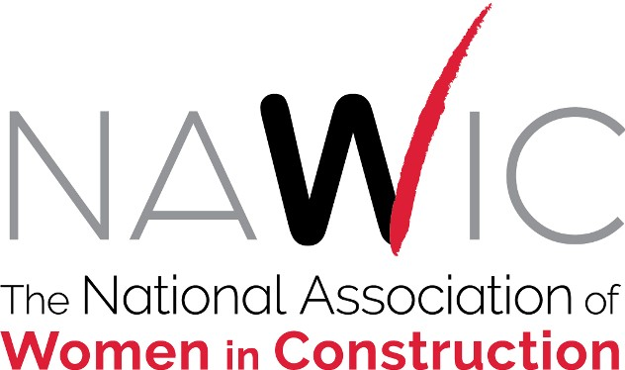

Pre-Conference Board of Directors Meeting
Wednesday, August 17, 2022
SUMMARY OF ACTIONS
- APPOINTED the following:
  - Vice President Karen Hager as Timekeeper for the Pre-Conference Meeting.
  - Rhonda Nebgen, South Central Region Director and Alison Frye, North Central Region Director as Audit Committee for the Pre-Conference Meeting.

- APPROVED Consent Agenda as amended
  - 20220804 Executive Committee Summary of Actions
  - 20220608 Board of Directors Meeting Minutes
  - 2021-2022 Audit
  - Officer Reports
    - President
    - President-Elect
    - Vice President
    - Secretary
    - Treasurer
    - Immediate Past President
    - Executive Director
    - Midwest Region Director
    - North Central Region Director
    - Northeast Region Director
    - Pacific Northwest Region Director
    - Pacific Southwest Region Director
    - South Atlantic Region Director
    - South Central Region Director
    - Southeast Region Director
  - Committee Reports
    - DE&I
    - Emerging Professionals
      - Liaison Report
    - Marketing
    - Membership
    - OSHA Alliance
    - PD&E
    - Strategic Planning

    - WIC Week
  - Taskforce Reports
    - Website

- APPOINTED the Chapter Development Committee Taskforce and appointed Crissy Ingram, Lauline Mitchell, Amber Kohut, Patty Lawson, Deb Lesar, Kizzy Ferrer, Anne Pfleger and Doreen Bartoldus to the task force

- PROVIDED DIRECTION for the Leadership Academy Taskforce

- APPROVED recommendation to continue the Industry Outreach Taskforce

- RETIRED the following Taskforces:
  - Director Coordinator
  - DEI MOSAIC TF for DEI Consultant Search

- RATIFIED the 2026 Annual Conference Location: Grand Sierra Resort in Reno, NV August 12 – 15, 2026

- APPROVED the Student Member Rate Proposal as published

- APPROVED the San Francisco, CA #19 Name Change Proposal to San Francisco Bay Area #19

- APPROVED the Grant Application Task Force Proposal on Preliminary Proposal Procedures as published.

- APPROVED the Budget Change to line item 5518 Strategic Planning to move forward with the DEI Consultant: Calling All Allies – Dr. Brandi Baldwin

- MOVED the 2021-2022 Bylaws Committee Report to 2022-2023 Bylaws Committee for consideration

- APPROVED pilot program of moving two Region Fund accounts to National account per Region Fund Transfer Taskforce Report

- APPOINTED the Midwest Region and Northeast Region to pilot the transfer of Region Fund accounts to National account

- MOVED the Chapter Officer Nominating Application Taskforce Proposal to the Bylaws Committee for review

